St. Bernard Confirmation Preparation:
A Guide to Live Out the Sacrament of Confirmation and a New Life in the Holy Spirit

SPONSOR GUIDE
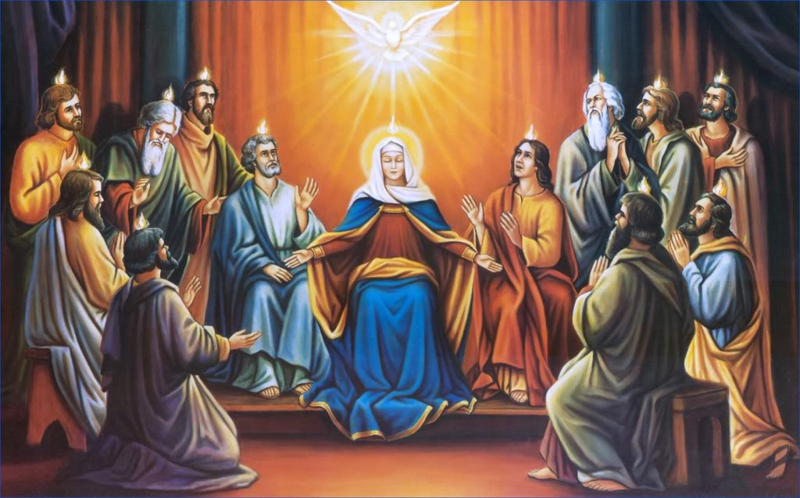

St. Bernard Parish
2040 Hillside Lane, Green Bay, WI 54302
Website: www.stbernardgb.org
(920) 468-4811
Coordinator: Callie Kowalski
callie@stbernardcong.org
(920) 468-4811, ext. 117
www.stbernardconfirmation.weebly.com
Why this process?
Confirmation is an extension of the Sacrament of Baptism – be aware that the Holy Spirit already lives inside of your soul. Confirmation preparation is a time to recognize and get to know more of the Holy Spirit. This is an invitation to get to know and experience the Holy Spirit in a deeper way, particularly through the receiving of the Sacrament of Confirmation, and is extended to all believers in Jesus Christ. It is an opportunity for spiritual growth through learning about the different aspects of the Holy Spirit and our faith. The only thing necessary for this process is openness to the movement of the Spirit.

In order to prepare individuals for more activity and experiences with the Holy Spirit, the Confirmation Preparation program is presented in 6 sessions: one opening retreat, 4 classes, and ending with a retreat. The program is aligned with fully-Catholic adaptation of the Catholic Charismatic Renewal’s Life in the Spirit Seminar, in addition to the Confirmation requirements presented by Bishop David Ricken and the Diocese of Green Bay. Please be advised that the class schedule and calendar will be provided for in a different document. Topics include the following:

April 2 [10am-5pm]: Opening Retreat – The Basics: Openness, God’s love, Confirmation
April 9 [4:30pm-6:30pm + Mass]: Class 1 - Salvation
April 23 [4:30pm-6:30pm + Mass]: Class 2 – New & Abundant Life: What our faith has to offer
April 30 [4:30pm-6:30pm + Mass]: Class 3 – God’s Gifts: Old Testament & New Testament
May 7 [4:30pm-6:30pm + Mass]: Class 4 - Release of the Holy Prayer Experience
May 21 [10am-5pm]: Commissioning Retreat – Going forth: how to live out your faith

This process allows students to enter more deeply into the Holy Spirit and recognize him even more in their everyday lives. There will be an opportunity for students to experience a release of the power of the Holy Spirit through a private time of prayer in front of the Blessed Sacrament and then coming together as Church and praying over each other. This does not take the place of any sort of reception of the Sacrament of Confirmation—it is to help the student to recognize the Holy Spirit in their personal and public prayer life.

More of the Holy Spirit
During the Last Supper, Jesus assured His disciples, “I will pray to the Father and He will give you another Advocate (Counselor), to be with you forever” (John 14:16). Jesus knew when He was no longer on earth, His disciples, limited to their own strength and ability, would not be able to live the kind of life to which He had called them. He pledged to them the very Spirit of God as a helper. Ten days after Jesus ascended into Heaven, and on the Jewish feast of Pentecost, the Holy Spirit assuredly came down upon and filled each of them with Himself. Ever since that time, the third person of the Trinity has remained with the Christian people

This experience of a personal Pentecost is a renewal of an individual. It is deemed an integral part of the renewal of the Church.

Openness and Participation
St. Bernard’s Confirmation Preparation Process is designed to bring students to their own personal decision of whether or not they truly want to receive Confirmation. Not everyone decides to receive Confirmation in 11th grade, and it’s perfectly fine to wait and receive it at a time that is better for the student; however, the preparation process will provide students with the tools they need to properly make this decision.
This entire process should be approached with OPENNESS. Students are asked to prayerfully consider why they are partaking in this journey. Participation in the classes, as well as involvement in small group sharing and other activities, will determine the readiness of students to receive the Sacrament. At the end of this entire process, students will be interviewed by one of our staff members to determine their openness and readiness to receive the Sacrament. Our entire Catholic faith is about RELATIONSHIP not REQUIREMENT. Parental involvement, particularly bringing the faith home, is extremely important in this entire process.
Building on the sacramental life of the Church, the Holy Spirit received in Baptism is being "fanned into flame," (2 Timothy 1:6). The flame is showing what Pope Benedict describes as “a burning reality” with confirmable results. This series will allow students to deepen their relationship with the Holy Spirit in order to fully receive the Spirit at Confirmation. Catholics filled with and led by the Holy Spirit are living a more deeply committed Christian life and each candidate of Confirmation is called to this. They are called to receive and use the gifts of the Holy Spirit, and contribute to a stronger spiritual life in Christian community within the universal Church.
Sponsors
This journey isn’t meant to be walked alone. Candidates are required to choose a Confirmation sponsor who should be present to them during the course of this formation process.
- A sponsor must be a Confirmed and practicing Catholic who attends Mass every Sunday and believes in the teachings of the Catholic Church.
- The sponsor CANNOT be one of the candidate’s biological parents.
- SPONSORS MUST BE CHOSEN BY MAY 21!

Requirements of Sponsors:
- Pray for your candidate and be available to them
- From end of May to late August, meet at least 3 times, and submit reports from these meetings
- Be available to attend the night of reflection in September, Confirmation Rehearsal, and Confirmation itself (all dates pending selection from the Diocese)
- Write a letter stating the candidate’s readiness to receive the Sacrament and how you will support the candidate for the rest of his or her life.

Topics for the summer meetings will be available via the website and reports can be email or submitted electronically. ALL REPORTS AND LETTERS ARE DUE BY SEPTEMBER 1

Basics of Prayer
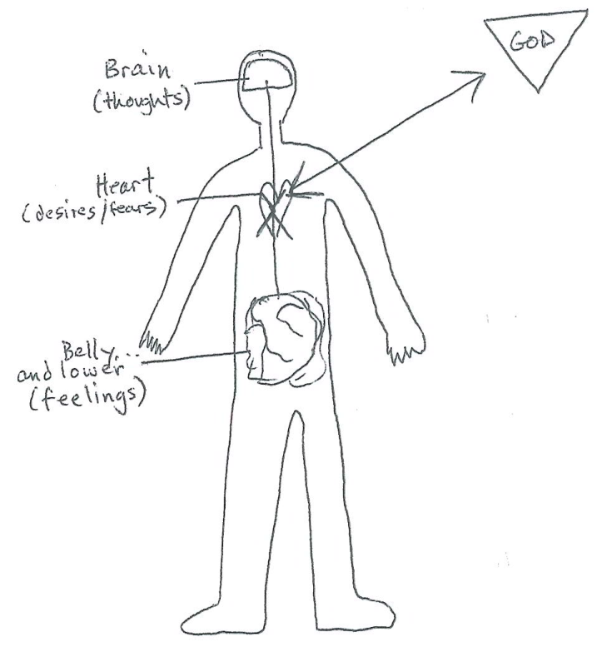
Encouragements for Prayer
- Builds a relationship with God
- Builds your identity
- Beloved son/daughter of God the Father
- Brother/Sister of Jesus, the Son
- Develops and strengthens your Mission

How do we have a relationship?
- Speaking
- Listening

“Pray like a pirate”
- Acknowledge any thoughts, feelings, desires, fears
- Relate them to the Father, the Son, the Spirit, Mary, etc.
- Receive a reply, often a sense of peace, joy, holy presence
- Respond with gratitude and with action if necessary
“The most fruitful human activity
is to be able to receive God.”
-Fr. Jean Corbon
“Our best conversations happen in silent intimacy,
with NO distractions, when our heart speaks to
the other’s heart.”
How to Develop a Prayer Life in 5 Easy Steps
- Aim for daily prayer—at least 5 minutes
- In the silence of your heart, become aware of His Presence
- Speak—ask for a specific grace or desire you need to draw closer to Him
- Listen…follow what He speaks to you. It might be little things at first but abide to His commands
- Thank Him and decide how to move forward

Spirit Alive

The Role of the Sponsor
Introduction & Responsibilities
The word “sponsor” comes from a Latin root meaning, “to give assurance” or “to promise solemnly.” A Confirmation sponsor walks with a candidate along the journey toward Confirmation and even after.

Confirmation is a sacrament, a sign of God’s grace, which gives us strength to witness to the Gospel of Jesus Christ. There are a lot of misconceptions about what Confirmation is, and what it’s “for.” It’s important to understand the sacrament’s true purpose. Confirmation allows us to be vibrant, joyful, and bold witnesses for Jesus Christ and his Church; to defend it, and to orient our lives around God’s will.

The most crucial things sponsors can do is to pray fervently and witness joyfully. Pray every day for your candidate. Witness your faith by attending Mass, serving others, and just being an excited, on-fire Catholic.

Being a sponsor is a beautiful opportunity to dive deeper into your faith with new eyes. It’s an opportunity for you to look at your faith in a different and new way. It’s too easy to look around in our churches and see people who are missing, but despite many challenges, there is always hope. As a Confirmation sponsor, you have an essential role in forming the future of our Church and our world. Come Holy Spirit! May the Lord help us on this important journey.
Responsibilities
PRAY. Above all else, this is probably the most important thing you can do for your candidate. Pray for them
but also pray that God will give you the grace to support and minister to your candidate in a personal and
sincere way. Pray also for the entire Confirmation class, their families, and teachers who are supporting them in this journey. Invite your candidate to discover new forms of prayer, especially the ones you use to connect with the Lord. Going to Mass with your candidate is a great way to meet with them!

LISTEN. The One-on-One sessions will allow you to have some good discussions with the teen you are
mentoring. Take your time getting to know your candidate.
-Sponsors are asked to meet with their candidate 3 (three) times between end of May and August. These meetings can be as long as you’d like but should be at least 30 minutes. You are encouraged to meet longer or more often than the basic requirement.
-A report needs to be filled out after each meeting and needs to be submitted by the end of that month’s meeting. You can submit a digital report on our website, email reports, or physically hand reports in by September 1st.

GUIDE. As a sponsor, you’ve been entrusted with a special role to lead your candidate closer to Jesus and the Church. During your discussions, if your candidate expresses doubt or disagreement with a belief or teaching
of the Church, affirm their honesty and openness. Remember, however, that the Church is guided by the Holy Spirit and that Her teachings on matters of faith and morals are protected from error. Encourage your
candidate to dive deep and wrestle with any difficult issues that come up, but remember to uphold the
teachings of the Church. If you’re unsure about something, feel free to contact Callie or Fr. Mark or Adam,
or look online at good resources such as Catholic Answers and the United States Conference of Catholic Bishops.

IMPORTANT DATES. Sponsors are REQUIRED to be present on Confirmation day itself (Sunday, May 1st at 1 PM). Outside of that, here are the following dates I ask sponsors to attend:
Wednesday, Sept 27th – 6 to 7:30 PM – Night of Reflection with Confessions
Sunday, October 8th – 3 PM Confirmation Rehearsal
Sunday, October 15th – 3 PM Confirmation Mass with Bishop David Ricken
Please report to Bishop Hall with your canddiate by 2:30 PM
Sponsors Guide to Candidate Meetings
- Familiarize yourself with your candidate’s prep. Your candidate has been meeting with the large group for six weeks. The introduction of this packet defines the process and topics we covered. However, asking your candidate what he/she experienced might be the best route.
  - Fr. Dave Pivonka, a Franciscan Friar, has put out an awesome video series that expands on the basic topics that we covered in our six-week process. You can view them at: www.thewildgoodisloose.com
- Review the current meeting guide that you are covering. There are 3 that you are asked to complete as a Sponsor with your candidate. They are specific topics that are designed to expand upon topics we covered in our large group.
- Take a look at Bishop Ricken’s Request for Confirmation Students. This list contains everything the Confirmation candidate must be familiar with in order to be considered for the Sacrament of Confirmation. Candidates are asked to memorize the sheet before their final interview in September.
- Check in with your candidate regarding their Confirmation Saint. By the time you meet with them, they will have already chosen their saint. Share with them your Confirmation saint, if you have one. Enlighten them to who you look up to in Heaven and why saints are important. Most importantly, listen to what they have to say.
- Attend Mass and/or Confession with your candidate if you are in the area. Receiving the Sacraments are vital for continuing a life of faith. Attending Mass or going to Confession with your candidate can only help you as a Sponsor and he/she as a Candidate. Encourage each other to attend Mass every Sunday!
- Summarize your meeting, report it back to the Coordinator. Visit the website to submit your report online: http://stbernardconfirmation.weebly.com/monthly-reports.html. Or email any reports to: callie@stbernardcong.org. All reports are due by Sept 1st

- Write a letter of recommendation for your Candidate. The letters should state why you think your candidate is ready for Confirmation and how you hope to help them along their life-long journey. Letters should not exceed 1 page in length, double spaced. All letters are due by Sept 1st and can be emailed or mailed/dropped off at the Parish Office.

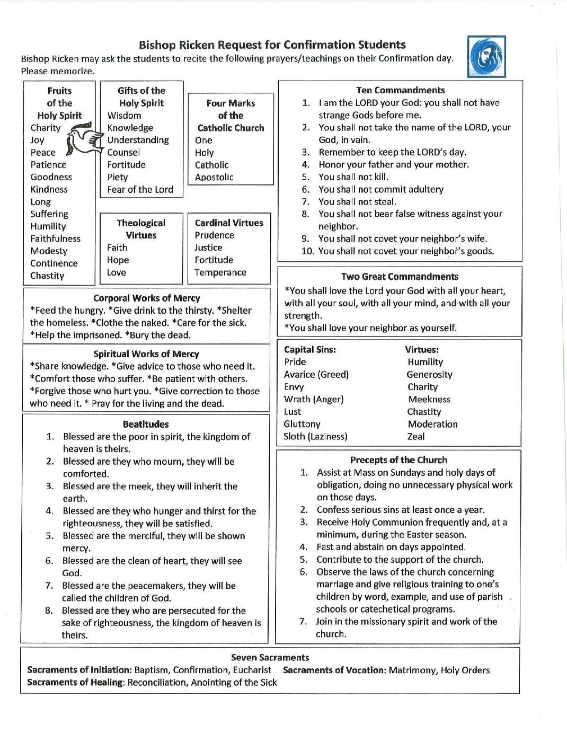

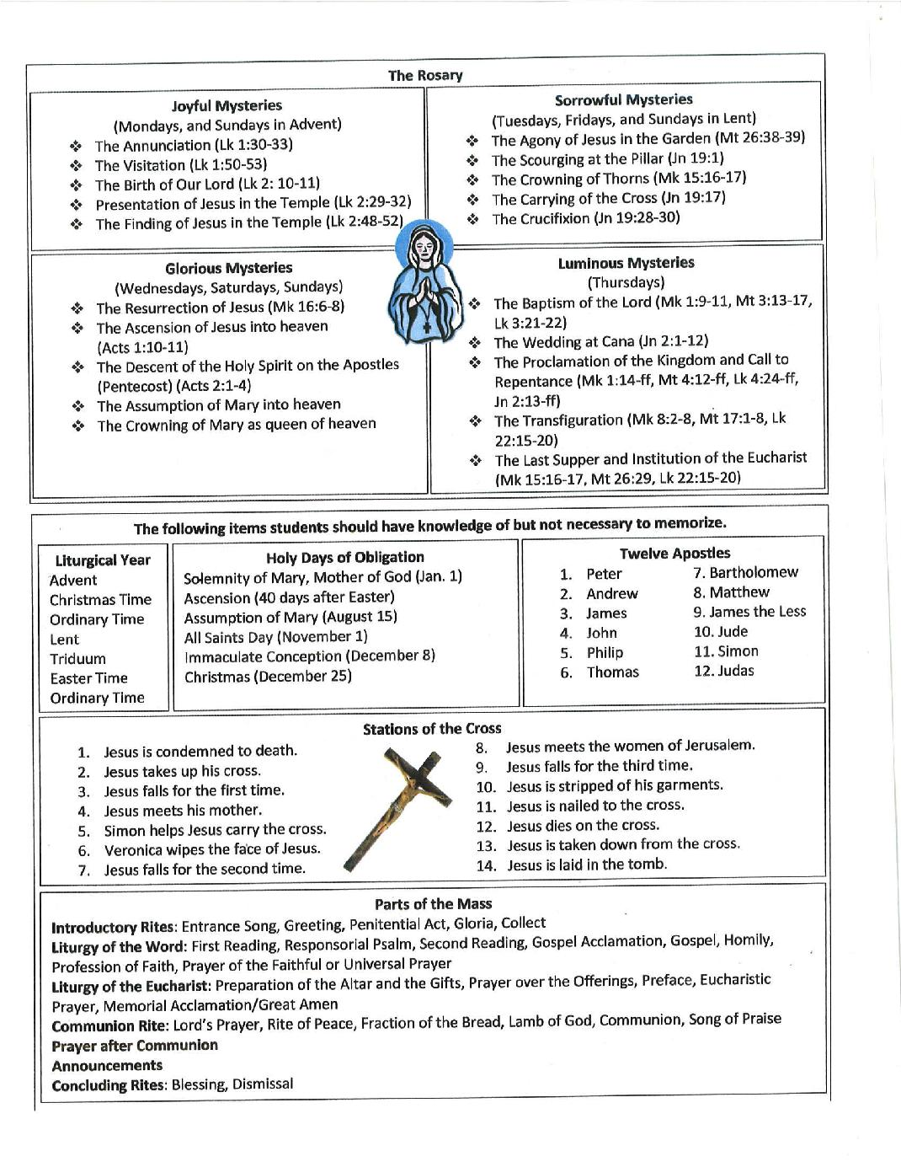

1st Meeting – God’s Love & His Promises
Background

The Old Testament sets the stage for the full expression of God's love in His Son Jesus. As we read and pray certain passages from the Old Testament, we can become more deeply aware of how much God does really love us. We need to know and experience God’s love if we are to develop into the people He wants us to be. This is especially important if we do not love ourselves as we should. Knowing our faults and failures and our sinfulness, we may question how God could really love us.

By praying with Sacred Scriptures we will become more aware and convinced of God’s total and unconditional love. This conviction that God loves us with an infinite love and that nothing we do will change this fact should be the foundation of our relationship with Him. We must come to know Him as a loving, kind, forgiving Father who welcomes His errant children with open arms. He is a Father who loves us more than we could ever imagine being loved. God, the Creator of the universe, the person who made all things out of nothing, loves us. He wants to care for us, share His divine life with us, and bring us into perfect union with Him, for all of eternity.

SCRIPTURE PASSAGES 1st John 4:7-11 Ephesians 2:4-5 John 3:16
REGARDING GOD’S LOVE: 1st Peter 5:6-7 Deuteronomy 7:9 John 13:34-35

When we are convinced that we are loved, only then can we be open and honest. Then there is no need for pretense or shame. Then we will begin to live in freedom and in sincerity.

An awareness of God's great love for us can lead us into a greater depth in our prayer lives. Deeply aware of His loving presence we want to whisper in the quiet of our hearts, "I love You too." This type of prayer of the heart is the beginning of contemplative prayer. As we experience His loving presence within us, we no longer require words or thoughts. We simply rest in His presence. We are aware of God; we are known and loved at the very core of our being. This becomes the basis for our whole spiritual growth.

First, we know with our minds that God truly loves, but then we must become convinced in our hearts so that we can respond to His great love. This conviction will be ours when we hear God Himself telling us of His great love for us. Listen to His word in the Scripture readings each day.

Breaking Down the Faith
1st Meeting: Discussion topics
Each meeting will have a section focusing on a couple different aspects of our faith to be discussed at your meeting. “Breaking Down the Faith” will expand on the Bishop’s Guide to Confirmation but will also focus on specifics popular items in our Church. Try to memorize or at least retain this information. You will also have a saint to focus on during this week.
The 2 Great Commandments [to be memorized] -----------------------------------------
- You shall love the Lord your God with all your heart, with all your soul, with all your mind, and with all your strength. [Mark 12:30]

- You shall love your neighbor as yourself. [Mark 12:31]
Take some time to reflect on these 2 Commandments. Together with your candidate, sit in silence for 5-10 minutes and ask what these Commandments mean to your candidate. Use the following questions to fuel your discussion. Please provide a report on what your meeting consisted of.
-What is your relationship like with God? Can you say that you actually love the Lord with all your heart, soul, mind, and strength?

-God created you in HIS image. In order to love others, you must love yourself. What does this mean to you? Does anything hold you back from loving others?
The Beatitudes -----------------------------------------------------------------------------The Beatitudes, by definition, are known as “exalted happiness.” They are often looked at as a supplement to the 10 Commandments and expand upon the Commandments to give us clear direction as to how to live out our faith. The Beatitudes come from Jesus’s “Sermon on the Mount” [Matthew 5:3-11].
Blessed are...
....the poor in spirit: for theirs is the kingdom of Heaven. (Matt 5:3)
....those who mourn: for they will be comforted. (Matt 5:4)
....the meek: for they will inherit the earth. (Matt 5:5)
....those who hunger and thirst for righteousness: for they will be filled. (Matt 5:6)
....the merciful: for they will be shown mercy. (Matt 5:7)
....the pure in heart: for they will see God. (Matt 5:8)
....the peacemakers: for they will be called children of God. (Matt 5:9)
....those who are persecuted for righteousness' sake: for theirs is the kingdom of heaven. (Matt 5:10)

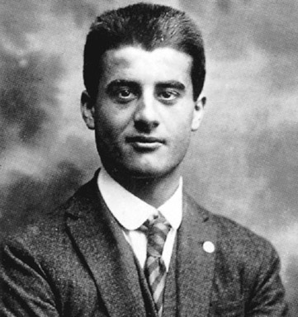
Blessed Pier Giorgio Frassati is on his way to becoming a saint in our Church. He is known as the “Man of Beatitudes” because he lived them out in his own life. Coming from a wealthy family, Pier Giorgio knew he was called to serve. He went out and ministered to the sick, the poor, and the needy. He also would play poker with his friends he’d bet if they lost that they would have to go to Mass with him. He ended up dying in his 20’s from tuberculosis which he contracted from ministering to the sick in his area .

1st MEETING: REPORT
Name of Candidate: __________________________________________
Name of Sponsor: ____________________________________________
Date of Meeting: __________________ Location: ___________________
Please provide a detailed report on your meeting. Write about where you had the meeting, what you reviewed, and what topic you covered in discussion. Did you pray any prayers together, if so, which ones? How do you think this meeting will help your candidate?
________________________________________________________________________________________
________________________________________________________________________________________
________________________________________________________________________________________
________________________________________________________________________________________
________________________________________________________________________________________
________________________________________________________________________________________
________________________________________________________________________________________
________________________________________________________________________________________
________________________________________________________________________________________
________________________________________________________________________________________
________________________________________________________________________________________
________________________________________________________________________________________
________________________________________________________________________________________
________________________________________________________________________________________
________________________________________________________________________________________
________________________________________________________________________________________
________________________________________________________________________________________
________________________________________________________________________________________
________________________________________________________________________________________

2nd Meeting – Holy Spirit, Gifts, Pentecost:
What does it mean to me?
Background

Throughout the ages, prophets predicted the day would come when God would give His Spirit freely to men. Those who turned to Him and received His Spirit would be changed. They would receive new life. We remember this event in the third glorious mystery of the Rosary, “The Descent of the Holy Spirit.”

Jesus' promise to fulfill that prediction happened on Pentecost when the disciples were gathered together in prayer and the Holy Spirit appeared in the form of tongues of fire. They began to prophesy and heal the sick; they prayed in tongues and proclaimed the Good News boldly. And thousands of Jews became believers in Jesus Christ as the Son of God.

We received the same Holy Spirit in our Baptism and His presence in us was strengthened in Confirmation. For many of us, however, the fullness of the Holy Spirit's action in our lives is still awaiting our invitation.

We can experience the Holy Spirit in the same way the first disciples did. And when the Holy Spirit is released more fully in us, we will begin to experience a new kind of life. We get to know God in a new way and we become changed people. Then, as we continue to grow in faith, we want to reach out and serve others. God equips us with the spiritual gifts we need to do His work.

Jesus told us, "I have come that you may have life and have it in abundance" (John 10:10). This abundant life is not only a promise of spending eternity with God in heaven but a new life here and now. We receive it by yielding to God to have Him more active in our lives.

As the candidate prepares for this important event of receiving the Holy Spirit in a deeper way through Confirmation and becoming a soldier for Christ, keep in mind that what happens to others may or may not be the same thing that happens to the candidate. As a Sponsor, pray for your candidate but also encourage your candidate to be completely open to the love that God wants to express personally to him or her in the days, weeks, months and years ahead. This is only the beginning of a life long journey with Jesus.

Encourage your candidate to be open to receiving all of the gifts of the Holy Spirit (see 1 Corinthians 12:1-11).

Breaking Down the Faith
2nd Meeting Discussion Topics
Tasks for this meeting: -read through and pray on the story of Pentecost, discuss: what does this mean for your faith and receiving Confirmation? -review the Gifts of the Holy Spirit, discuss: why are these gifts so important and what gifts could you use more of at the moment?
Story of Pentecost -------------------------------------------------------------------------
In your Bible: Acts 2:1-13

When the time for Pentecost was fulfilled, they were all in one place together, and suddenly there came from the sky a noise like a strong driving wind, and it filled the entire house in which they were. Then there appeared to them tongues as of fire, which parted and came to rest on each one of them. And they were all filled with the holy Spirit and began to speak in different tongues, as the Spirit enabled them to proclaim.
Now there were devout Jews from every nation under heaven staying in Jerusalem. At this sound, they gathered in a large crowd, but they were confused because each one heard them speaking in his own language. They were astounded, and in amazement they asked, “Are not all these people who are speaking Galileans? Then how does each of us hear them in his own native language? We are Parthians, Medes, and Elamites, inhabitants of Mesopotamia, Judea and Cappadocia, Pontus and Asia, Phrygia and Pamphylia, Egypt and the districts of Libya near Cyrene, as well as travelers from Rome, both Jews and converts to Judaism, Cretans and Arabs, yet we hear them speaking in our own tongues of the mighty acts of God.”
They were all astounded and bewildered, and said to one another, “What does this mean?”

7 Gifts of the Holy Spirit ------------------------------------------------------------------
1. Wisdom 2. Understanding 3. Counsel 4. Courage 5. Knowledge 6. Piety 7. Fear of the Lord [to be memorized]
Wisdom: See things the way God would. Understanding: allows us to grasp the Truths of the faith.
Counsel: Figuring out the best decision, judgment, guidance. Courage: Supernatural strength.
Knowledge: Gives us the ability to judge what is right and wrong. Piety: perfection of religion, the desire to pray and get closer to God. Fear of the Lord: to praise God, to be in wonder and awe.

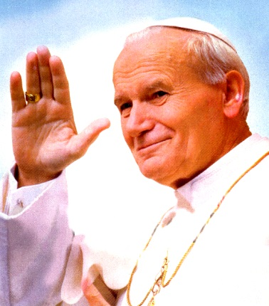
St. Pope John Paul the Great is recognized as helping to end Communist rule in his native Poland and eventually all of Europe. He significantly improved the Catholic Church's relations with Judaism, Islam, the Eastern Orthodox Church, and the Anglican Communion. He upheld the Church's teachings on such matters as artificial contraception & the ordination of women, but also supported the Church's 2nd Vatican Council & its reforms. He was one of the most travelled world leaders in history, visiting 129 countries during his pontificate. As part of his special emphasis on the universal call to holiness, he beatified 1,340 people & canonized 483 saints.

2nd MEETING: REPORT
Name of Candidate: __________________________________________
Name of Sponsor: ____________________________________________
Date of Meeting: __________________ Location: ___________________
Please provide a detailed report on your meeting. Write about where you had the meeting, what you reviewed, and what topic you covered in discussion. Did you pray any prayers together, if so, which ones? How do you think this meeting will help your candidate?
________________________________________________________________________________________
________________________________________________________________________________________
________________________________________________________________________________________
________________________________________________________________________________________
________________________________________________________________________________________
________________________________________________________________________________________
________________________________________________________________________________________
________________________________________________________________________________________
________________________________________________________________________________________
________________________________________________________________________________________
________________________________________________________________________________________
________________________________________________________________________________________
________________________________________________________________________________________
________________________________________________________________________________________
________________________________________________________________________________________
________________________________________________________________________________________
________________________________________________________________________________________
________________________________________________________________________________________
________________________________________________________________________________________

3rd Meeting – Growth through Ongoing Conversion
Background

To some extent we all have a limited view of God. We confine His actions in our lives to what we think and expect Him to do. But as we grow in our relationship with Him, we recognize more completely who He really is. We recognize His role in life’s “coincidences” and in the goodness that flows from people who are close to him. Growth in love is always a manifestation of the Holy Spirit within us, working through us and upon us.

This new life in the Spirit is not something to be experienced only at youth groups, or in a church on Sunday, or in our prayer closet, or alone by ourselves. This new life means just that, a changed life, a new person, different from what we used to be. And this change is a growing experience, a daily walk (and struggle) in a new life.

Nourishment is a necessity for growth. As we strive to put our Catholic faith into action, daily prayer will be a must. Scripture reading and meditation is a must. Listening to God is a must. Through our devotion and meditation, through self-discipline and the encouragement of others, the Father will direct our continued life-in-the-Spirit.

As Catholics we can anticipate a deeper devotion and love for the Eucharist and commitment to Eucharistic Adoration. Our lives will revolve around Jesus and the Mass. A hunger for scriptural understanding and spiritual reading will be aroused. Satisfy this hunger by reading. Follow these inclinations and desires of your heart. Do not stifle these quiet inner suggestions by thinking they are ridiculous or by putting them aside.

Encourage your candidate in the following: As you continue to grow, there will be times when you feel the intensity of God's love. Bask in God’s love and enjoy it, for there will also be days when your spiritual life seems dry, and God seems distant. These dry desert times provide a different kind of opportunity for continued growth, provided you maintain your devotion to daily prayer, scripture reading and listening to God. Growing in Christ is similar to growing like a child. There are times when you will jump, run, skip, laugh, and delight in your relationship with Jesus. There will also be times when you stumble, slip, and skin your knee when you fail to listen or disobey.
Our Lord is love. He is always there ready to pick us up and to address all our feelings and all our needs, but we must give Him the freedom to move.

Breaking Down the Faith
3rd Meeting – Growth Through On-Going Conversion
Tasks for this meeting: -review the 4 Marks of the Church and the Precepts, discuss the importance of these and what they mean for your faith as a sponsor, and in your candidate’s faith. Action: come up with a strategic plan on to how to live faith in your everyday life, including getting to Mass every Sunday.
4 Marks of the Church [to be memorized] -------------------------------------------------
- ONE
Just as God is one in the Father, Son, and Holy Spirit, so also is the Church one.
- APOSTOLIC
The Church traces its tradition directly from the apostles. The Holy Spirit has guided the Church
- CATHOLIC
“Catholic” means universal. The Church is universal by baptism and the Church’s mission.
- HOLY
The Church is holy because the Church lives in union with Jesus Christ, the source of holiness.

Precepts of the Church [to be memorized] -------------------------------------------------
- Assist—attend and participate—at Mass on Sundays and Holy Days of Obligation, doing no unnecessary physical work.
- Confess serious—mortal—sin at least once a year.
- Receive Holy Communion frequently, and at minimum, during the Easter season—you still need to go to Mass, but need to be free of mortal sin in order to receive the Eucharist.
- Fast and abstain on appointed days. If you do not know these days, please see the list
- Contribute to the support of the church—financially or in other ways—if you are good at singing, give back to the church by using your gift in the choir. We are always looking for more ushers, lectors, servers to help at Mass.
- Observe the laws of the church, particularly the ones concerning matrimony, and give religious training to children by word, example, use of parish schools or catechetical programs.
- Join the missionary spirit and work of the church. Attend a mission trip with our youth group, sign up to teach a religion class on Wednesday nights, join the choir if you are musical.

Confirmation is a point of strengthening your faith to go out and be a soldier for Christ. How are you going to live out your Confirmation?
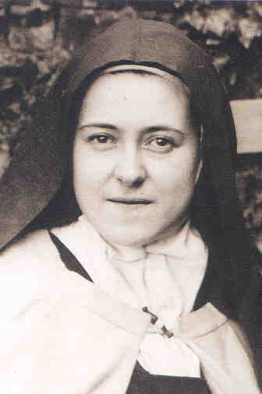
St. Therese of Lisieux died at the young age of 24 but contributed so much to the Church that she became a Doctor of the Church. She is known as the “Little Flower” due to the simplicity of the way she lived out her faith. She loved people in the “little way.” Even though she desired to travel and be a missionary, she felt called to the reclusive life of the Carmelites and devoted her life to deep prayer and penance. She suffered immensely from tuberculosis which ended up taking her life. She wrote tirelessly in order to express her deep love for Jesus and the Church.

3rd MEETING: REPORT
Name of Candidate: __________________________________________
Name of Sponsor: ____________________________________________
Date of Meeting: __________________ Location: ___________________
Please provide a detailed report on your meeting. Write about where you had the meeting, what you reviewed, and what topic you covered in discussion. Did you pray any prayers together, if so, which ones? How do you think this meeting will help your candidate?
________________________________________________________________________________________
________________________________________________________________________________________
________________________________________________________________________________________
________________________________________________________________________________________
________________________________________________________________________________________
________________________________________________________________________________________
________________________________________________________________________________________
________________________________________________________________________________________
________________________________________________________________________________________
________________________________________________________________________________________
________________________________________________________________________________________
________________________________________________________________________________________
________________________________________________________________________________________
________________________________________________________________________________________
________________________________________________________________________________________
________________________________________________________________________________________
________________________________________________________________________________________
________________________________________________________________________________________

Sponsor Letter to Recommend Candidate for Sacrament
Directions & Purpose
As a sponsor, your role in the candidate’s spiritual journey goes beyond these 3 meetings. This journey as a sponsor should be life-long, guiding them on the road of faith until the moment they return home to the Lord. That being said, the Coordinator asks every sponsor to submit a letter defining: how you view your role as a sponsor, what you are hoping to do in the future to support your candidate, and whether or not your feel as if your candidate is ready and able to receive the Sacrament of Confirmation. In this letter, please also refer to your meetings and what meeting or discussion stood out most to you as a sponsor. Feel free to add any experience you have as a sponsor or how you would compare your journey to Confirmation to your candidate’
The letters should be no more than 1 page in length, 12 point Times New Roman font, double-spaced. They can be typed or hand written but should contain the aspects listed above. Please turn in your letter, along with the final meeting reports, to the Coordinator of Confirmation, Callie Kowalski, at the Parish Office: 2040 Hillside Lane, Green Bay by SEPTEMBER 1ST.
Letters can follow this format:
Current Date
Your Name
Address
City, State, & Zip Code
Dear Callie,

(Body of Letter—consisting of no more than 1 full page, double spaced including the topics listed above)

Sincerely,

(Your name, first and last )
(Best way to contact you)

Candidate’s Letter to Bishop

Your candidate is required to submit a letter to Bishop Ricken stating their request to be Confirmed, a reason why they wish to be Confirmed, and a plan stating how they hope to live out their Confirmation in their life. They have the format of what the letter should look like, and with the assistance of their sponsor, they are asked to write this letter

Letter to Bishop Ricken stating your intention to receive Confirmation
Bishop David Ricken requires a letter of intention from every Confirmation candidate prior to the student receiving the Sacrament. This is a way for Bishop to have an idea as to whether or not each candidate is prepared, ready, and responsible to receive the Sacrament of Confirmation. Remember: Receiving Confirmation is not a “graduation” but it is just the beginning to your adult life in the Catholic faith.
Please take this letter seriously. I will be reviewing them before sending them out and Bishop Ricken will read every letter he receives. This letter is a reflection on how open you are to receive this Sacrament, so please be honest, open, and respectful, but most importantly, please share your thoughts with Bishop at this time. It’s an opportunity for him to see the state of faith the youth is in in our Diocese.
- All letters must be typed with 12 point Arial or Times New Roman font.
- The body of the letter (not including the conclusion) must be AT LEAST 3 paragraphs. Each paragraph must be AT LEAST 4 sentences.
  - The next page lists some ideas on what to cover in your letter
- The letter can be either typed or hand-written but it is preferred that you type it. However, final letters are to be physically handed in to Callie. DO NOT MAIL IN YOUR LETTERS! Your letter should be printed out, signed by you, and then dropped off at Parish Office by SEPTEMBER 1.
WHAT TO PUT IN THE BODY OF THE LETTER
This is your opportunity to let the Bishop know who you are.
- State your request for Confirmation.
- Introduce yourself: state your name, school, age, hobbies, family and interests
- How do you feel about your decision to be Confirmed? Why do you want to be Confirmed?
- How have grown in your understanding of this Sacrament since the start of your classes?
- List one way the Holy Spirit has moved in your life since you started this process. (This can include any trips you’ve gone on: includingthe March for Life, Steubenville, SHINE)
- How is your prayer life? What do you do every day to connect to God?
- Who is your sponsor? Why did you choose him/her? How has this person helped you in your journey?
- What service projects have you completed?
- Things of impact (importance) to you in your preparation
  - Who is your patron saint?
  - Have you explored any scripture verses that have helped you in this preparation?
  - How have your parents helped you on this journey?
- How do you plan to live and grow in your faith in the years to come?
  - Particularly at home, school, and in our Church
- What are your plans for next year?
- You can end your letter by thanking Bishop Ricken for reading your letter and giving you the opportunity to receive the Sacrament.
Appendix A
Practical Ways to Live Out your Confirmation

With Family and Friends:

- Show the love you have for God in word and action. If you have difficult relationships, pray for guidance on how to handle things and trust the Holy Spirit to show you what to say and/or do.

- Forgive someone who has wronged you. Ask for forgiveness from someone you have wronged. Try to keep doors open in these important relationships.

- Be open to share your personal faith story of how God has worked in your life when the opportunity arises. Ask the Holy Spirit to bring you circumstances where “the time is right” to tell your story. If you feel shy or uncomfortable, practice what you might say.

- Invite others to join you for Mass, a parish activity, or attending prayer group without indicating a sense of judging where they are spiritually.

- “Preach the gospel at all times – if necessary, use words.” Be an example on how a believer in Jesus Christ acts and speaks. Actually live out your faith. Don’t be afraid to say “no” to the things of this world

At Mass:

- Be friendly and move to the center of the church pew because that is an occasion for others to join you and offers an opening to meet those you do not know.

- Smile and share the love of God in you with others especially during the Sign of Peace.

- Pray for opportunities to share your story of faith with others.

In the Parish:

- Serve your parish as an usher, a Eucharistic minister, lector, choir member, whatever area you sense God is leading you in.

- Invite someone to attend youth group events and go with them.
(you can stay updated on youth group events by joining our Facebook Group: St. Bernard Youth Ministry)

- Become a catechist or small group leader to have the opportunity to share your faith.

In the Diocese:

- Attend annual youth conferences, summer trips, and Steubenville conference.

